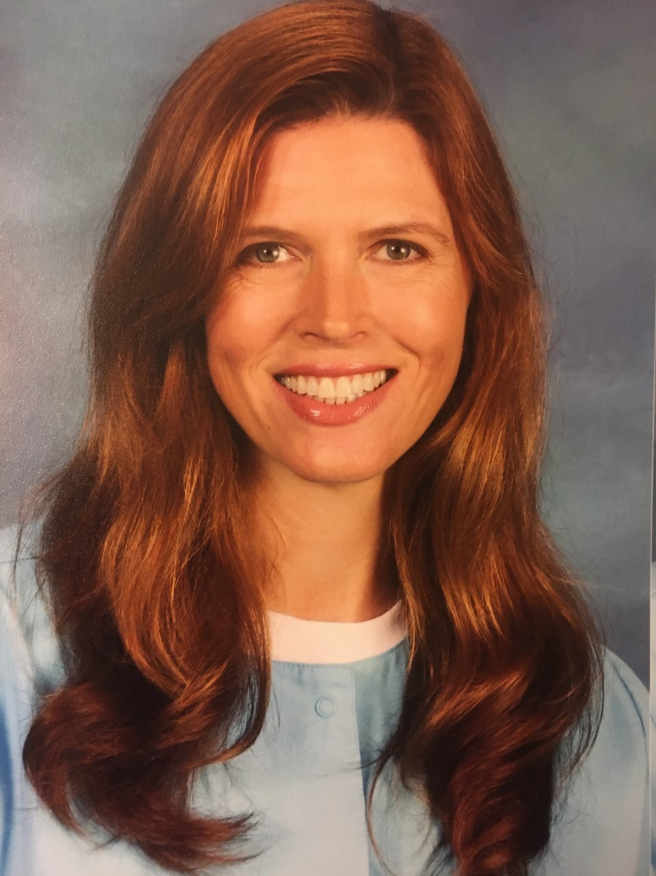

As the School Nurse at Northside Elementary School, Julie Vogel has seen everything from broken bones, sore throats and ear infections to poison ivy, concussions and allergic reactions. She even had a student zip their eyelid into the zipper of their jacket.

Vogel received her BSN from UNC-Charlotte and she is a Registered Nurse as well as a National Board Certified School Nurse. She decided to go into nursing when she realized that the field could blend all of the things that are important to her in a job.

“Nursing is a wonderful blend of science, social connection, meaningful and fulfilling work and tremendous job security with great flexibility,” said Vogel.

Prior to working as a school nurse, Vogel worked as a nurse in a variety of different areas of medicine. She has worked with leukemia patients, traveled as a research monitor for a drug trial, learned how to perform EKGs, worked in a busy Manhattan dermatology practice that pioneered laser treatments and assisted with Lasik and cataract surgeries. She loves her job at Northside Elementary because of the unique opportunities that it provides to create relationships with the students and staff.

“I had a student who I gave medication to each day and we got in the habit of exchanging jokes each time. My favorite one he told me was ‘Why can’t you trust an atom? Because they make up everything!’” said Vogel.

However, her job doesn’t come free of difficulty. In particular, the beginning of the school year is an exceptionally stressful time.

“The start of school is like trying to drink from a fire hose,” said Vogel.

Elementary schools usually have hundreds of immunization records and health assessments to review, but often parents forget to bring these records in. These records are incredibly important to ensure that the school is a safe and healthy place for students to learn. The start of school also brings parents who come to drop off medication for their children, often without the necessary form signed by them and the child’s healthcare provider. Even with this difficulty, Vogel takes it upon herself to ensure that students have their necessary medication by contacting and sending forms to the students’ health care providers herself.

When she isn’t working, Vogel enjoys spending time with her daughter and traveling. She has visited eleven countries including Morocco, Peru, Thailand, Japan and Cambodia among others.

Nurse Vogel urges anyone looking into nursing to continue in their pursuit of a nursing degree even if they aren’t attracted to certain parts of the job.

“You don’t have to enjoy giving shots and drawing blood to be a successful nurse,” said Vogel.

Vogel also asks the Chapel Hill-Carrboro community to reinforce the healthy living lessons that she, as well as the rest of the CHCCS staff, try to teach and instill in the students. She urges parents to be role models for their children by preparing healthy meals, exercising, refraining from smoking cigarettes, wearing their seatbelts and bike helmets, getting their flu shots and wellness exams each year and placing a high value on their health.

“Remember that your body is the only place you have to live in,” said Vogel.

During this pandemic, Nurse Vogel wants her community to know that she is still invested in the health of her students.

“I would like for my community to know that I am available to answer questions and provide assistance. I am available by phone, text, and email,” said Vogel.